**Bugs report**

**1.**

Title - **Symbol Search**

Severity

Low

Description

When you search for random series of symbols you are shown a list of books that does not fit the search

Steps

1. Open the Kindle app
2. Tap on the search bar on the top of the screen

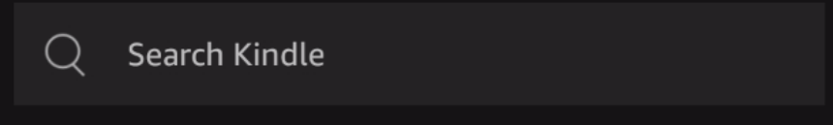

1. Type in random series of symbols for example: #$%^♡♡ and then tap on the magnifying glass on the bottom right of the keyboard 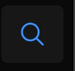

Expected results

The search will not be able to find books that fit the search or you will be shown a list of books that has at least one of the symbols

Actual results

Kindle search shows a list of books that has no connection to the searched symbols

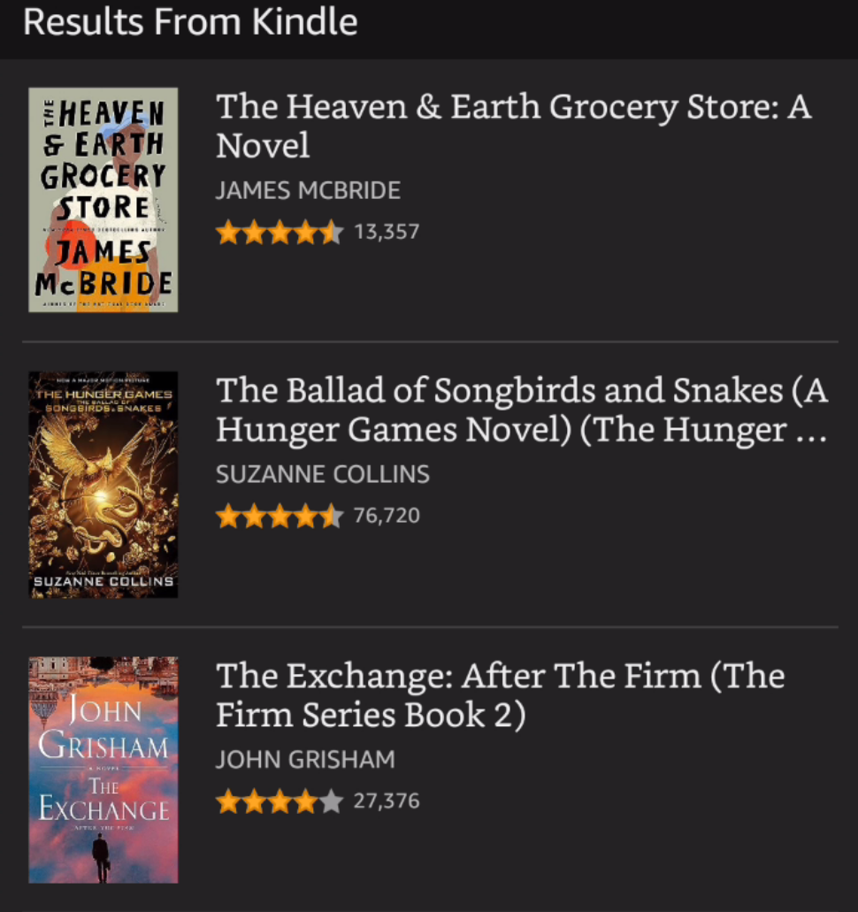

**2.**

Title

**Search Redirection**

Severity

Low

Description

When you open a book series you own from the search results and then tap back you are redirected to your library screen instead of back to the search results page

Steps

1. Open the Kindle app
2. Tap on the search bar on the top of the screen



1. Type a series of books you own i.e: Batman

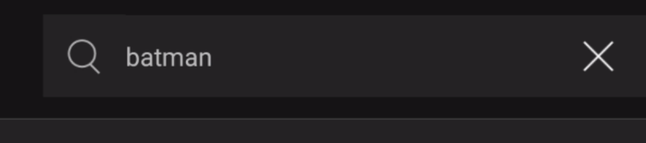

1. Tap on a series of books you already own to open the series

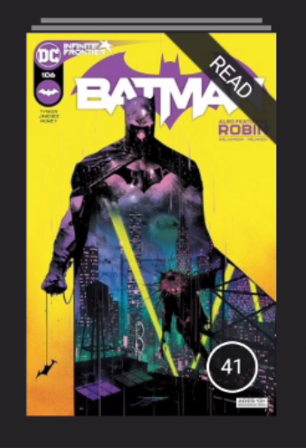

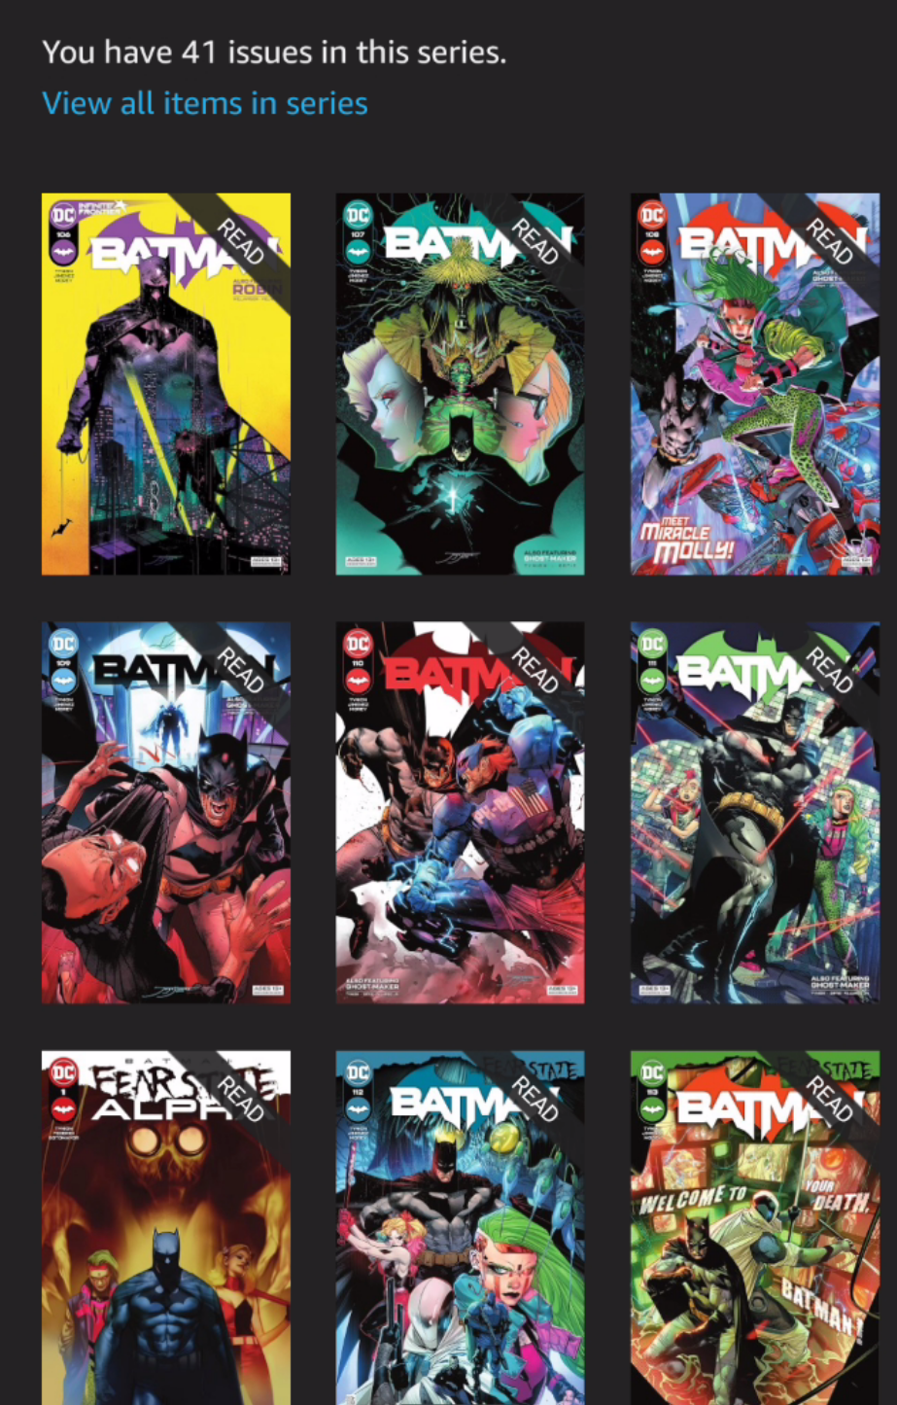

1. Tap back on the top left of the screen



Expected results

You will be redirected back to the search results page

Actual results

You are redirected to your library screen instead

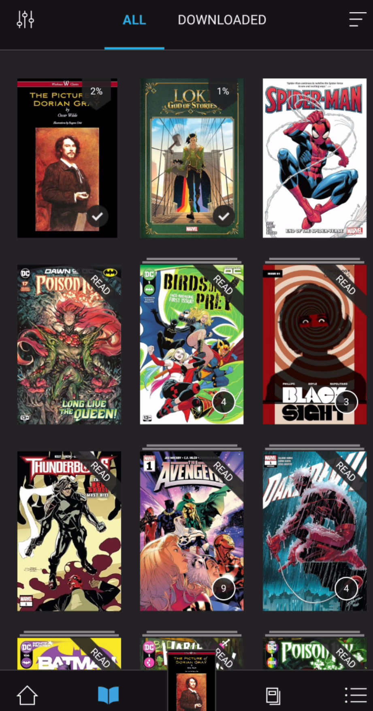

**3.**

Title

**Kindle Unlimited**

Severity

Medium

Description

There is a page dedicated to all the information on the Kindle Unlimited subscription, but there is no link or explanation how to subscribe

Steps

1. Open the Kindle app
2. Tap Explore on the explore navigation bar on the top of the screen beneath search

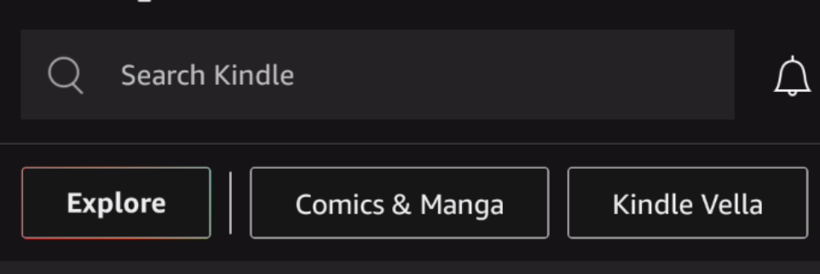

1. Tap on the first option that appears before the categories list: Kindle unlimited

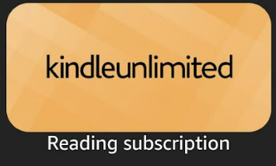

Expected results

You will be redirected to the kindle Unlimited page who will contain all the information and subscribe options to the service

Actual results

In the Kindle Unlimited there are only the details of the subscription and no information on how to subscribe to it.

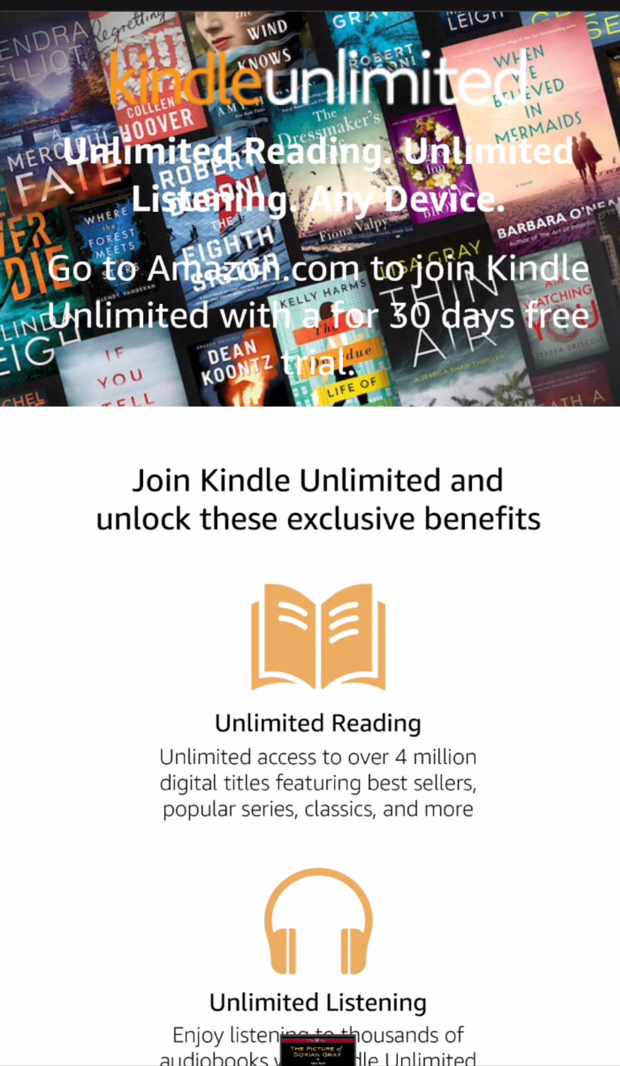

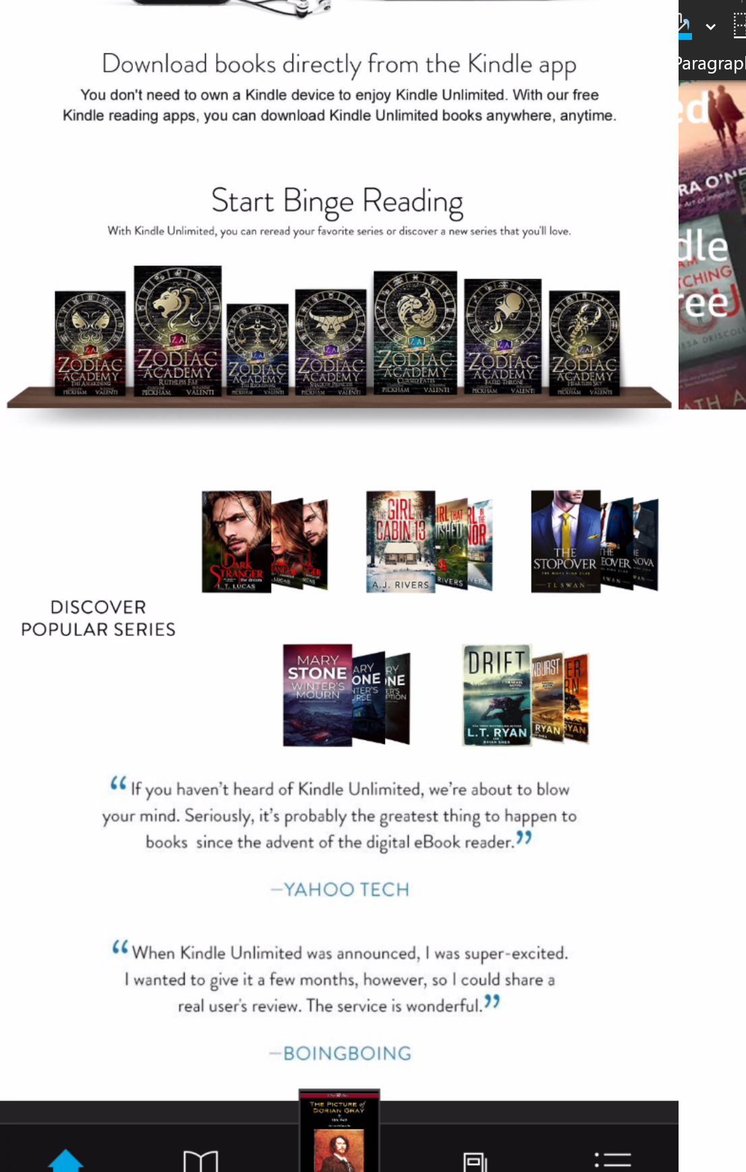

**4.**

Title

**Books Information**

Severity

Medium

Description

When you are recommended books that fits your reading history you can’t see the name of the books or the author. When the book has not come out yet, you are only shown a picture of the publication without any other information. You have to click on the picture to see the book’s information.

Steps

1. Open the Kindle app
2. Tap on the first book in the “From your library” section

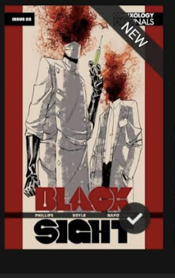

1. Tap once on the screen
2. Tap on the 3 dots on the top right of the screen



1. Tap on “about this book”



Expected results

In the more by the author, you will see information of more books from the same author including the name of the book

Actual results

The is no visible information about the book

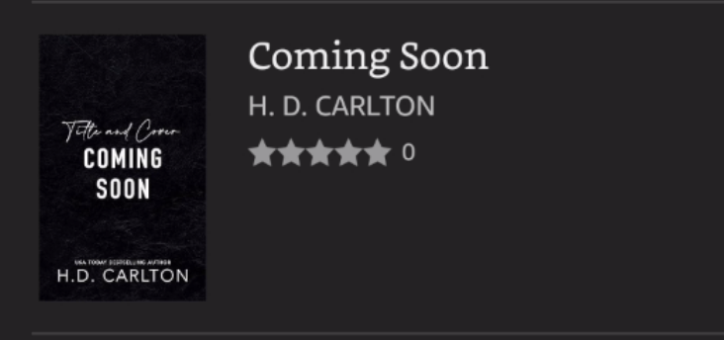

**5.**

Title

**Book Counter**

Severity

Low

Description

On the title read section there are some books that are counted twice

Steps

1. Open the Kindle app
2. Tap on the reading insights section

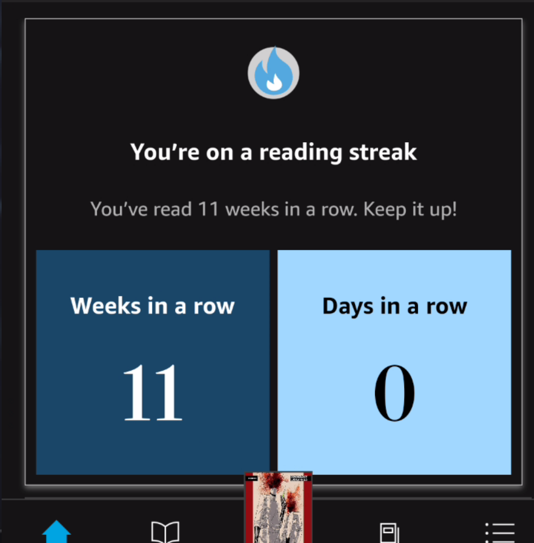

1. Swipe left on the second section in the reading insights page “what you’ve finished” to view all the books you have read this year

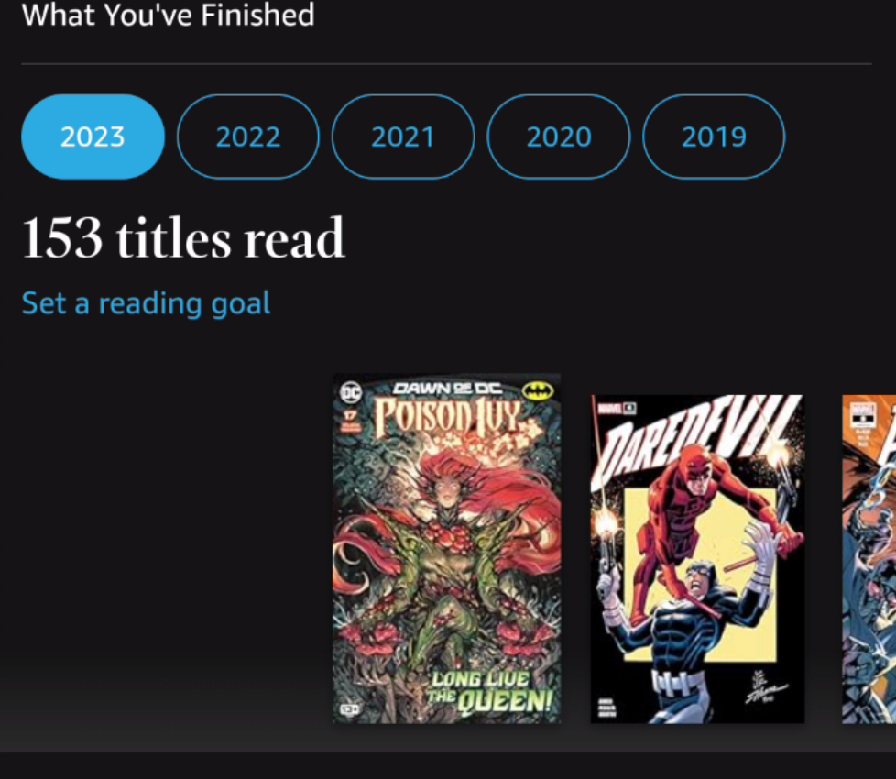

Expected results

You will see a correct number of how many books you have read this year

Actual results

Some books are counted twice for no apparent reason

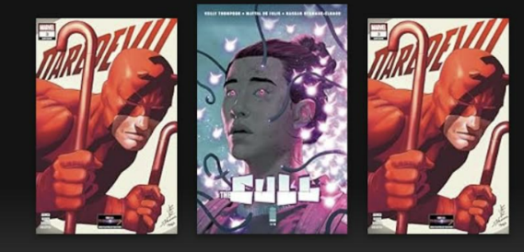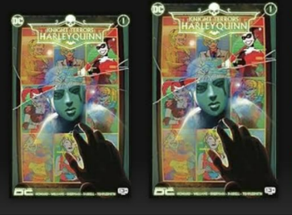

**6.**

Title

**Books Details**

Severity

Medium

Description

On the “recommended for you” section of the home screen only the books cover photos appear

Steps

1. Open the Kindle app
2. Scroll down to the “recommended for you” section and scroll left

Expected results

You will have all the information of the books recommended like name and author

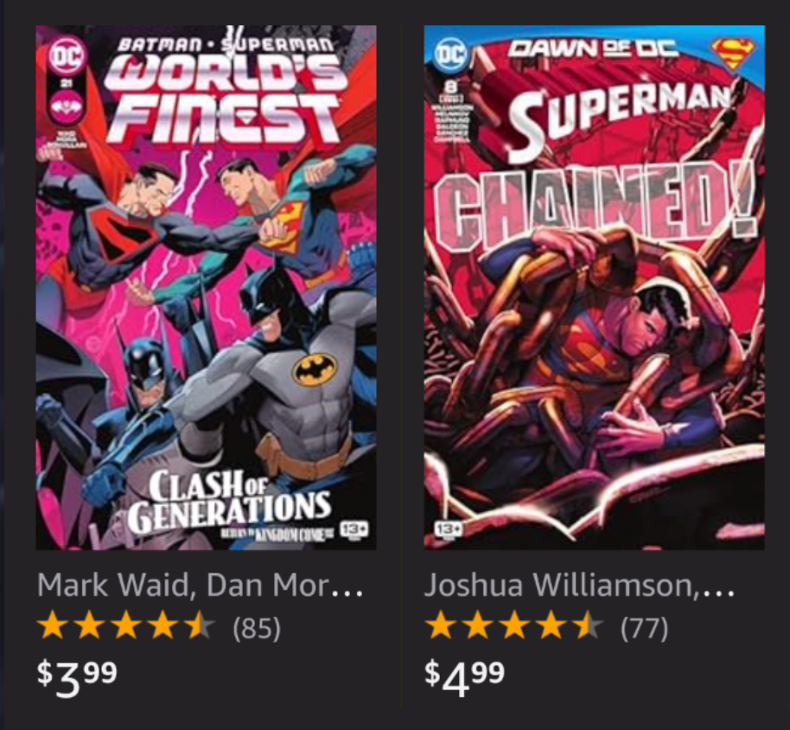

Actual results

You can only see the cover picture

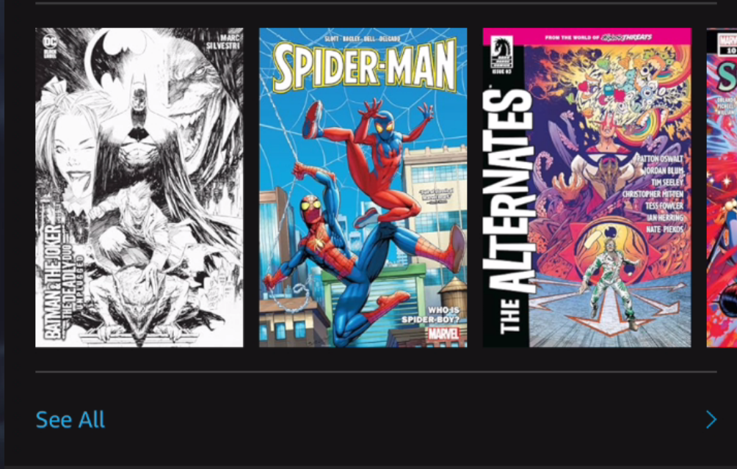

**7.**

Title

**Group Series**

Severity

Medium

Description

Some books from the same series are not connected to the series and appear as stand alone. This makes finding the next book in the series harder.

Steps

1. Open the Kindle app
2. On the bottom of the screen tap library

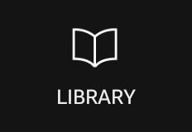

1. On the top left side of the screen tap on view



1. Tap on the “group by series” option



Expected results

All the books that belong to the same series will be grouped together in one bundle

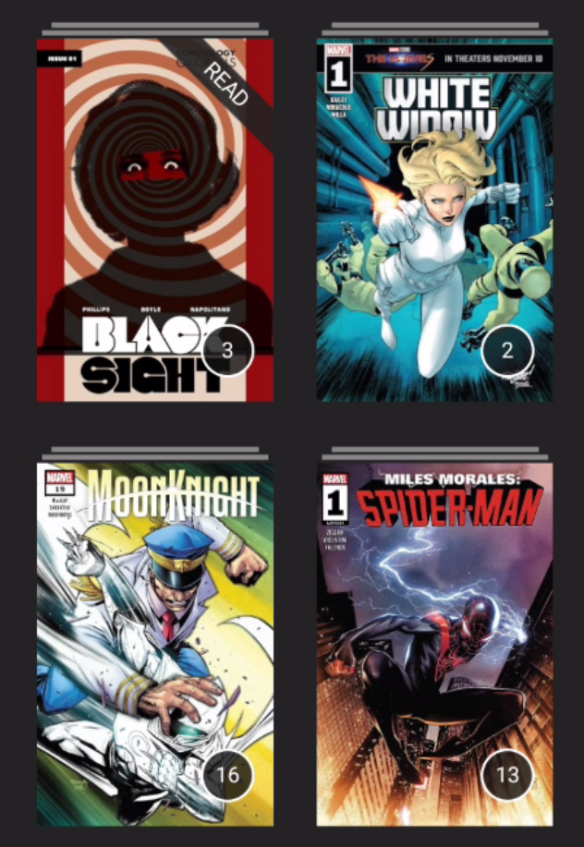

Actual results

Some books are not grouped to their series and stay in the library page as a stand-alone book

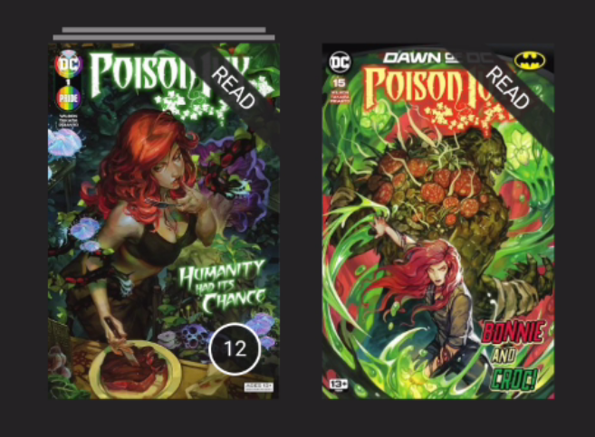

**8.**

Title

**Guided View**

Severity

Low

Description

The guided view option only works manually by double clicking the screen and not through the guided view option in the menu.

Steps

1. Open the Kindle app
2. Tap on a book to open it
3. Tap once on the screen
4. Tap on the “reading settings” option on the top right of the screen



1. Tap on open in guided view

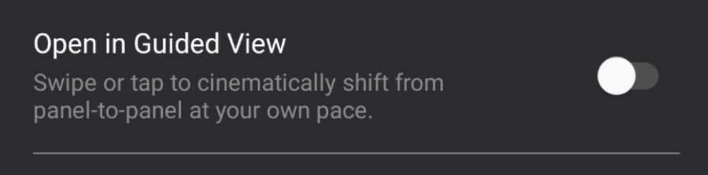

Expected results

The book will be presented in guided view

Actual results

The book does not open in guided view, not even after killing the app and opening the app again

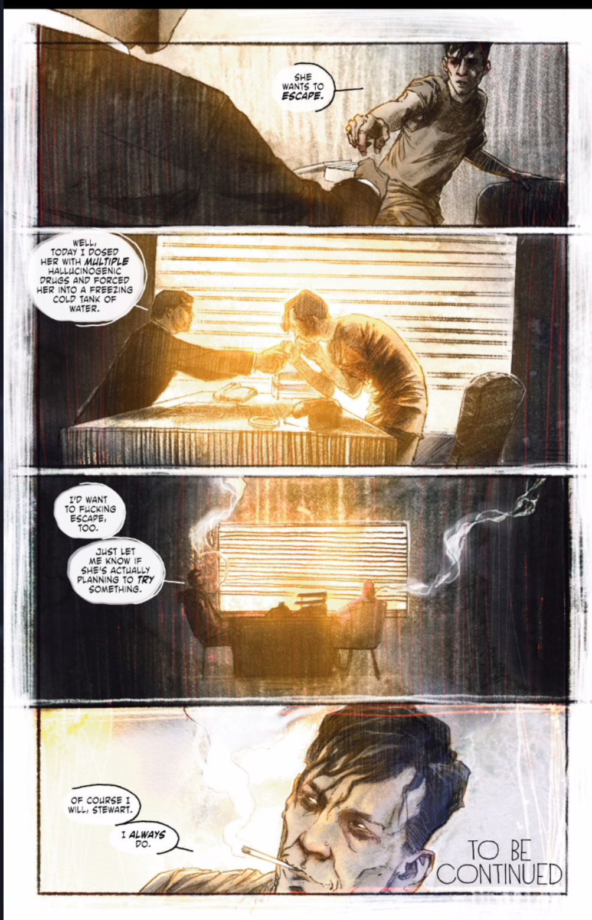

**9.**

Title

**Downloading “Heavy Books”**

Severity

High - This bug was reported to Amazon and had been fixed

Description

When you try to download and read a “heavy book” (a comic with 200+ pages) the book is marked as downloaded but the pages do not appear

Steps

1. Open the Kindle app
2. Tap on a heavy book to download it
3. When downloaded tap on the book to open it

Expected results

You can read the book with no problems

Actual results

You can’t read the book.

When downloading the book, the green progress line only reaches half way and then jump to “downloaded” status. The book can not be read.

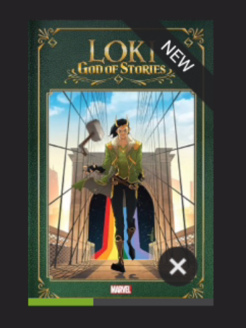 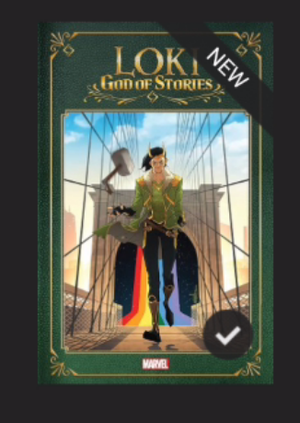 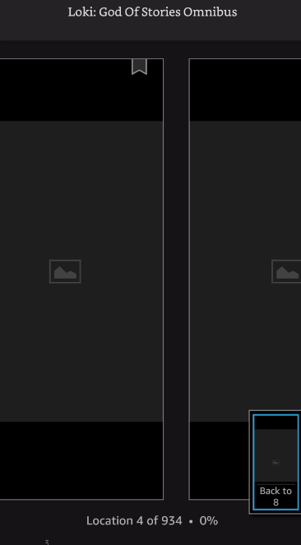

**10.**

Title

**Share Progress - GUI**

Severity

Low

Description

When you try to share your progress on a book the share option window say “recommend the book”.

Steps

1. Open the Kindle app
2. Tap on a book to open it
3. Tap once on the screen
4. Tap on the 3 dots on the top right of the screen



1. Tap on the share progress option



Expected results

A window will open with share progress option

Actual results

A window with recommend the book option opened instead

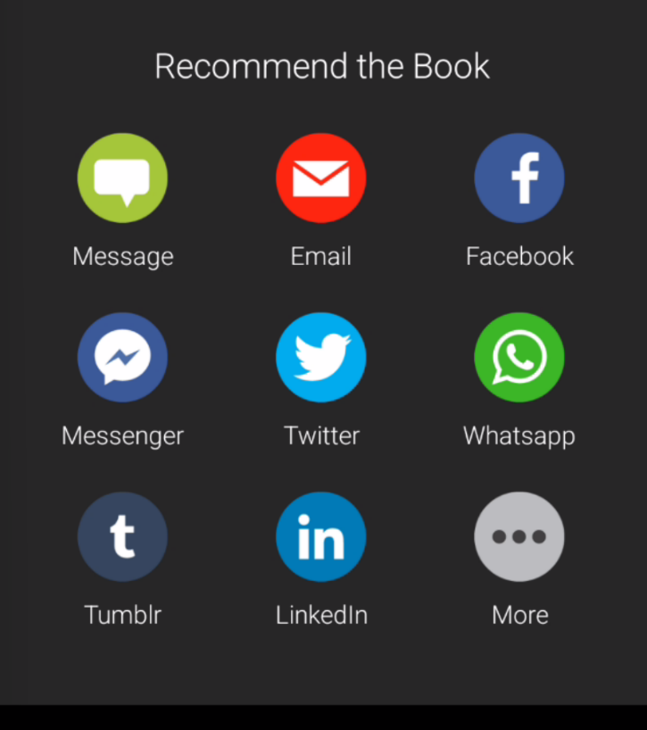

**11.**

Title

**Share Progress**

Severity

Low

Description

When you try to share your progress on a book the link that is being shared is just a link to the book.

Steps

1. Open the Kindle app
2. Tap on a book to open it
3. Tap once on the screen
4. Tap on the 3 dots on the top right of the screen



1. Tap on the share progress option



1. Tap on the WhatsApp icon

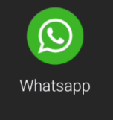

1. Pick a contact to share your progress with
2. Send your progress

Expected results

Your contact will receive a link with your progress information

Actual results

Your contact has received a link to the book with no information about your progress

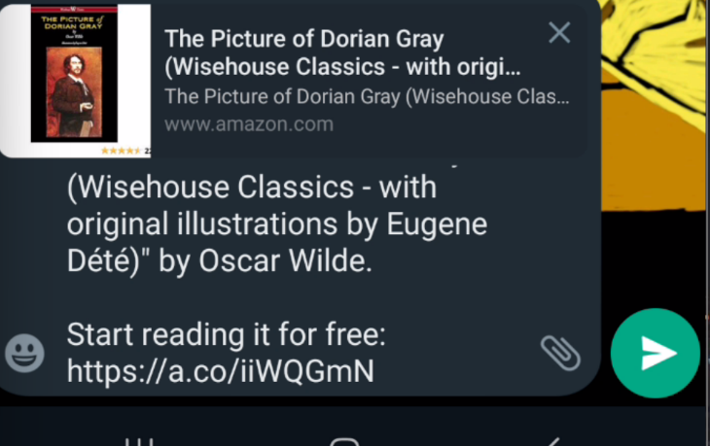

**12.**

Title

**Page search**

Severity

Low

Description

When you try and search for a page number that does not exist the app show you the last page of the book.

Steps

1. Open the Kindle app
2. Tap on a book to open it
3. Tap once on the screen
4. Tap on the 3 dots on the top right of the screen



1. Tap on go to page



1. In a book with 111 pages search page 414

Expected results

You will receive an error message saying the page is not found

Actual results

You are directed to the page before last of the book (110)

